# Droning

## Droner Selection

When 2 or more squad members are clearing or pushing an area, if droning is required, a Droner must be selected. The following diagram indicates the who in the group will be the Droner.



The diagram ensures that no unnecessary ‘double droning’ occurs when 2 or more members are droning simultaneously while no ground is being gained, resulting in a slow push and wasted time.

An easy way to think about it is: Left Role – Action (indicated by colour) - Top Role.

### Examples:

* Hard Support drones for Flex / Flex is droned by Hard Support
* Second Frag drones for Entry Frag / Entry Frag is droned by Second Frag
* Entry Frag drones for self, Entry Frag / Entry Frag is droned by self, Entry Frag

## Following a Drone

When Being droned by a teammate, hold position outside the target area until the entire area has been droned and the Droner has proper Line-Of-Sight on the next area. This ensures you cannot be unexpectedly pushed from the next area while acquiring the Target area.

### Examples:

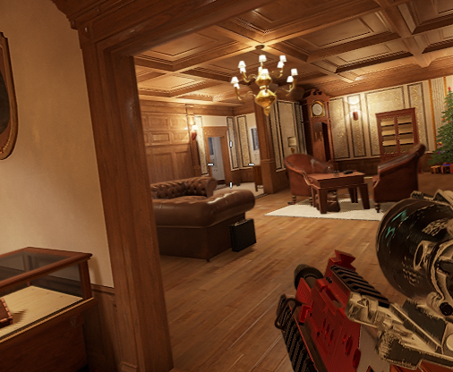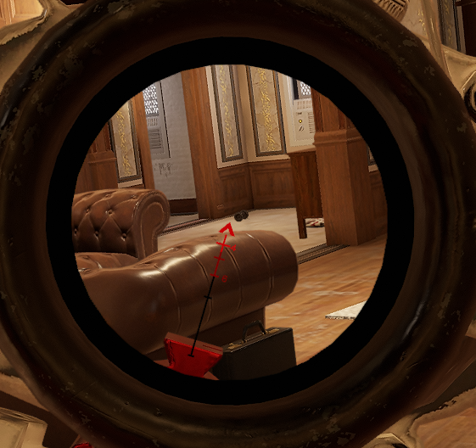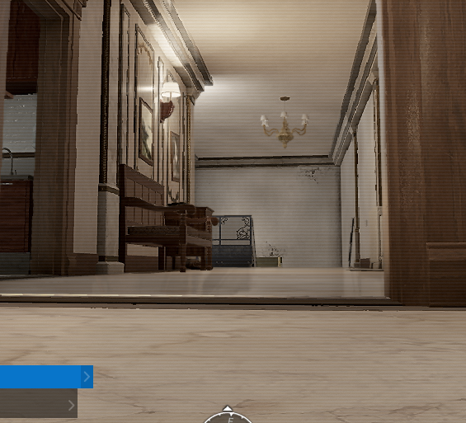

In the above example, Cigar Lounge has been completely droned and the Droner has Line-Of-Sight on White Corridor.

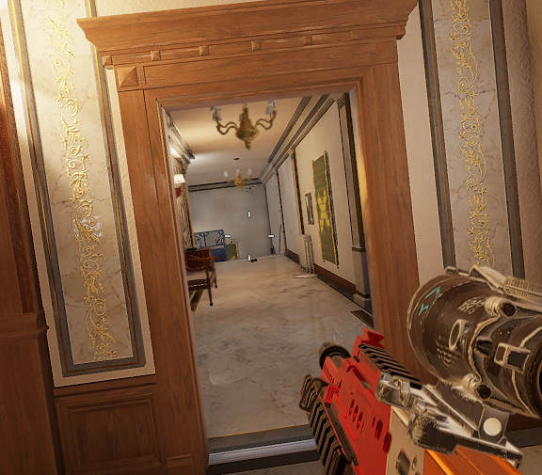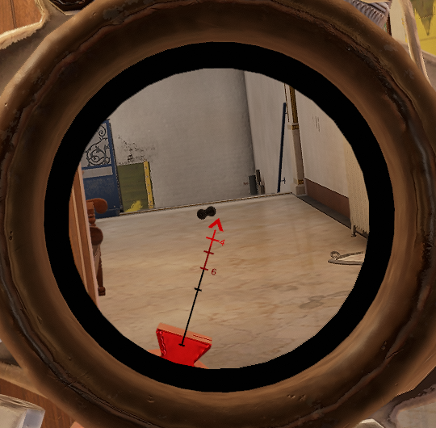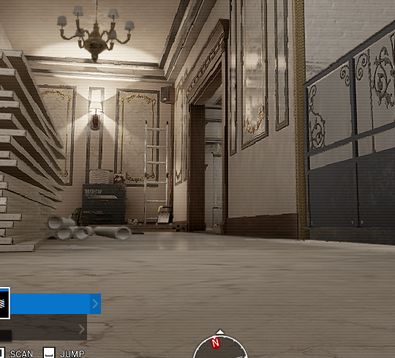

Again, in the above Example, White Corridor has been Completely droned and Droner has Line-Of-Sight into Cocktail Lounge.

# Terminology

## Callouts

### Stairs

There are 2 common types of stairs.

|  |  |  |
| --- | --- | --- |
| Name | Characteristics | Diagram |
| Straight | These stairs have **no landings or hard** **angles**. **Spiral stairs** also fall into this category. |  |
| Dog-Leg | These Stairs have a **definite hard angle**, most commonly 90 or 180 degrees, accompanied by a **landing**. |  |

#### 2 Floors

##### Straight

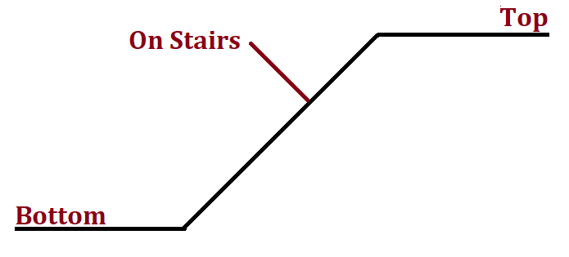

##### Dog-Leg

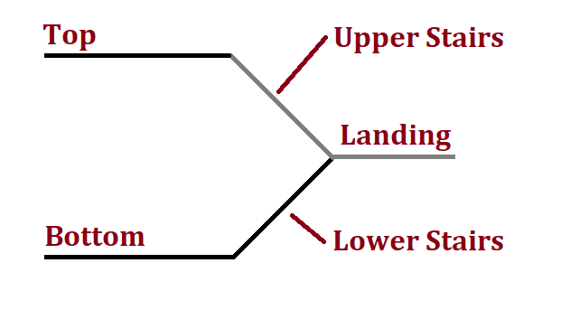

#### 3 Floors

##### Straight

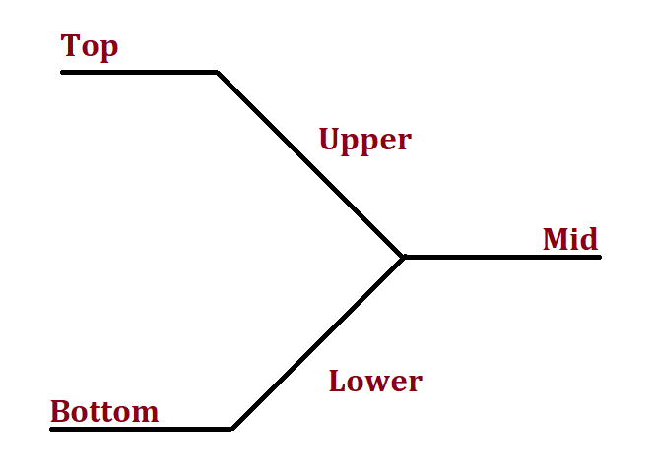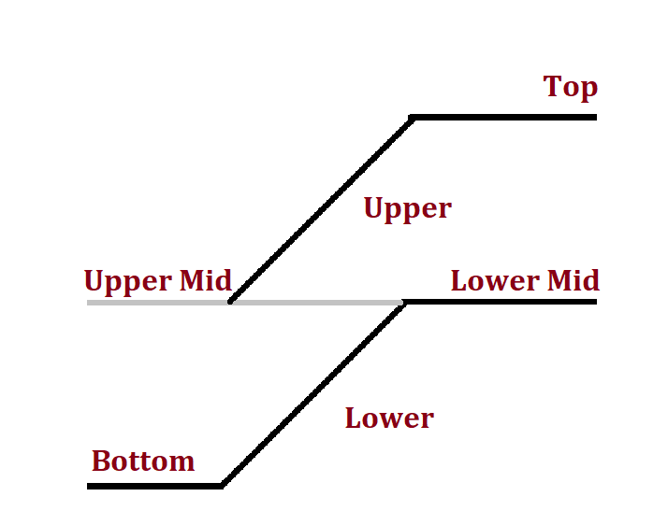

##### Dog-Leg

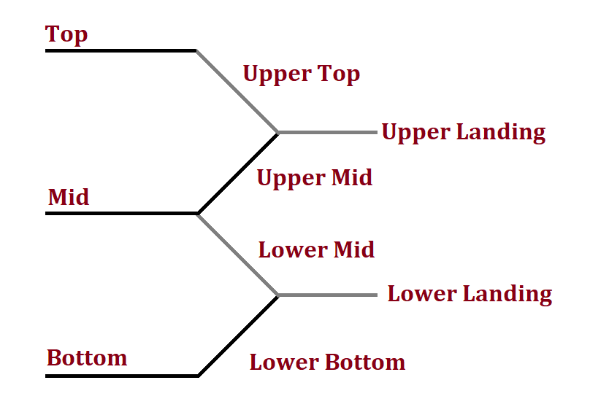

### Rooms

#### General

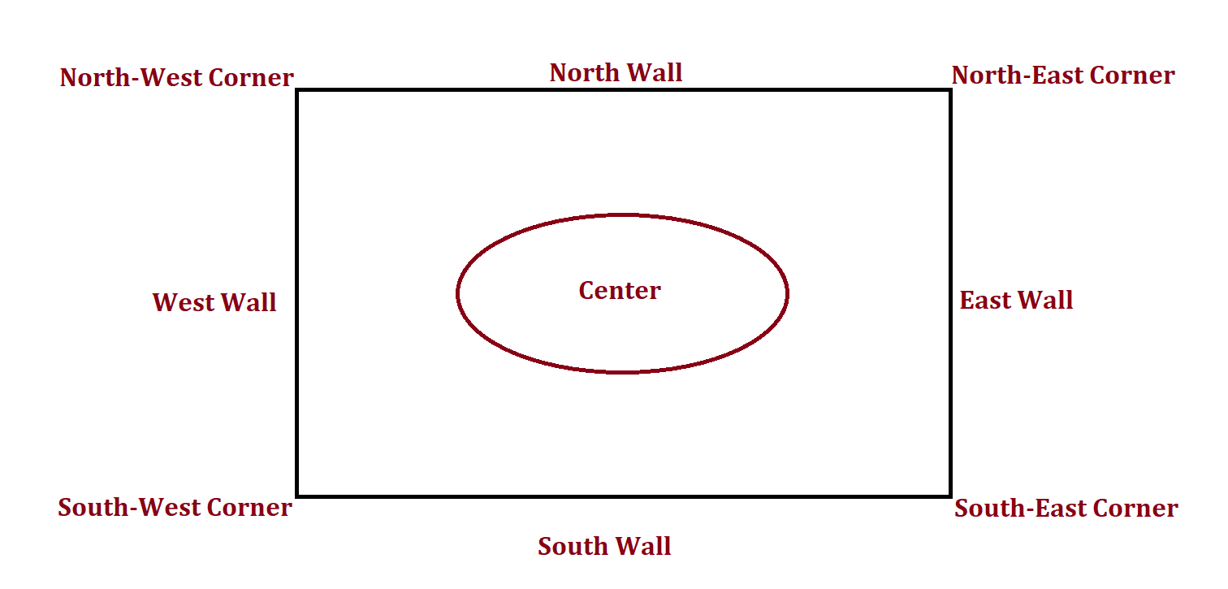

#### Relative to Player

